**The Excel Office Scripts JD Salinger Word Generator**

**Contents**

* My Salinger Year
* Operating the Salinger Word Generator
* The Power Automate Flow
* Further Notes
* GitHub Repo location
* YouTube Video Location
* The Office Scripts
* JDSalingerTypoGenerator
* JDSalingerArrayInput3
* JDSalingerArrayInput4
* Web References
* Appendix 1 Retrieved JSON for definition of word “DOWN”
* Appendix 2 Retrieved JSON for definition of word “TODAY”
* Appendix 3 The JD Salinger Literary Works

**My Salinger Year**

My Salinger Year (also known as My New York Year) is a 2020 drama film written and directed by Philippe Falardeau, based upon the memoir, of the same name, by Joanna Rakoff. It stars Margaret Qualley, Sigourney Weaver, Douglas Booth, Seána Kerslake, Colm Feore and Brían F. O'Byrne.

**"I am quiet emotional".**

After attending a recent cinema screening of "My Salinger Year", in 2021, it occurred to me that Excel could help with creating typos just like JD Salinger wanted. This demo app uses a new programming language called Office Scripts to create new three letter words. An online dictionary was added to the solution so that the definitions, if they, exist appear alongside the newly generated words.

**Fig 1. JD Salinger Word Generator App using Excel Office Scripts**

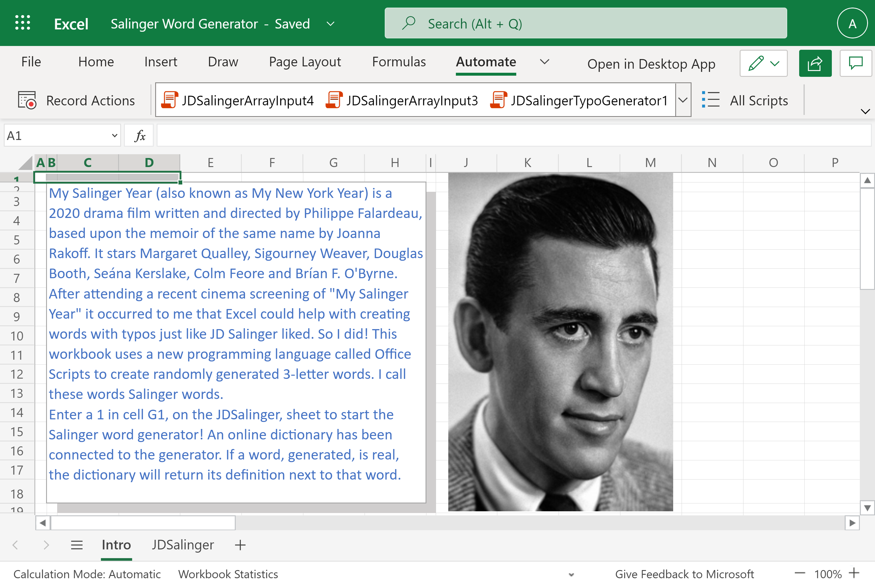

JD Salinger is famous for writing the following literary works:

• The Catcher in the Rye (1951)

• Nine Stories (1953)

• Franny and Zooey (1961)

• Raise High the Roof Beam, Carpenters and Seymour: An Introduction (1963)

• Odds and Ends

**Operating the Salinger Word Generator**

In order to operate the Salinger Word Generator enter a 1 in cell G1 to start the run. It takes around 100 seconds for each run to complete the word generation and the dictionary definition retrieval.

Here is the result of one run. See Fig 2. Of the twenty words generated, two words, “sic” and “dpc” do exist Their definitions appear in column C.

The Office Script brings spell checker and word definition functionality into Excel which, currently, is very limited in the Excel Online tool. The script can be amended to retrieve synonyms, also.

**Fig 2. The Salinger Word Generator after one run.**

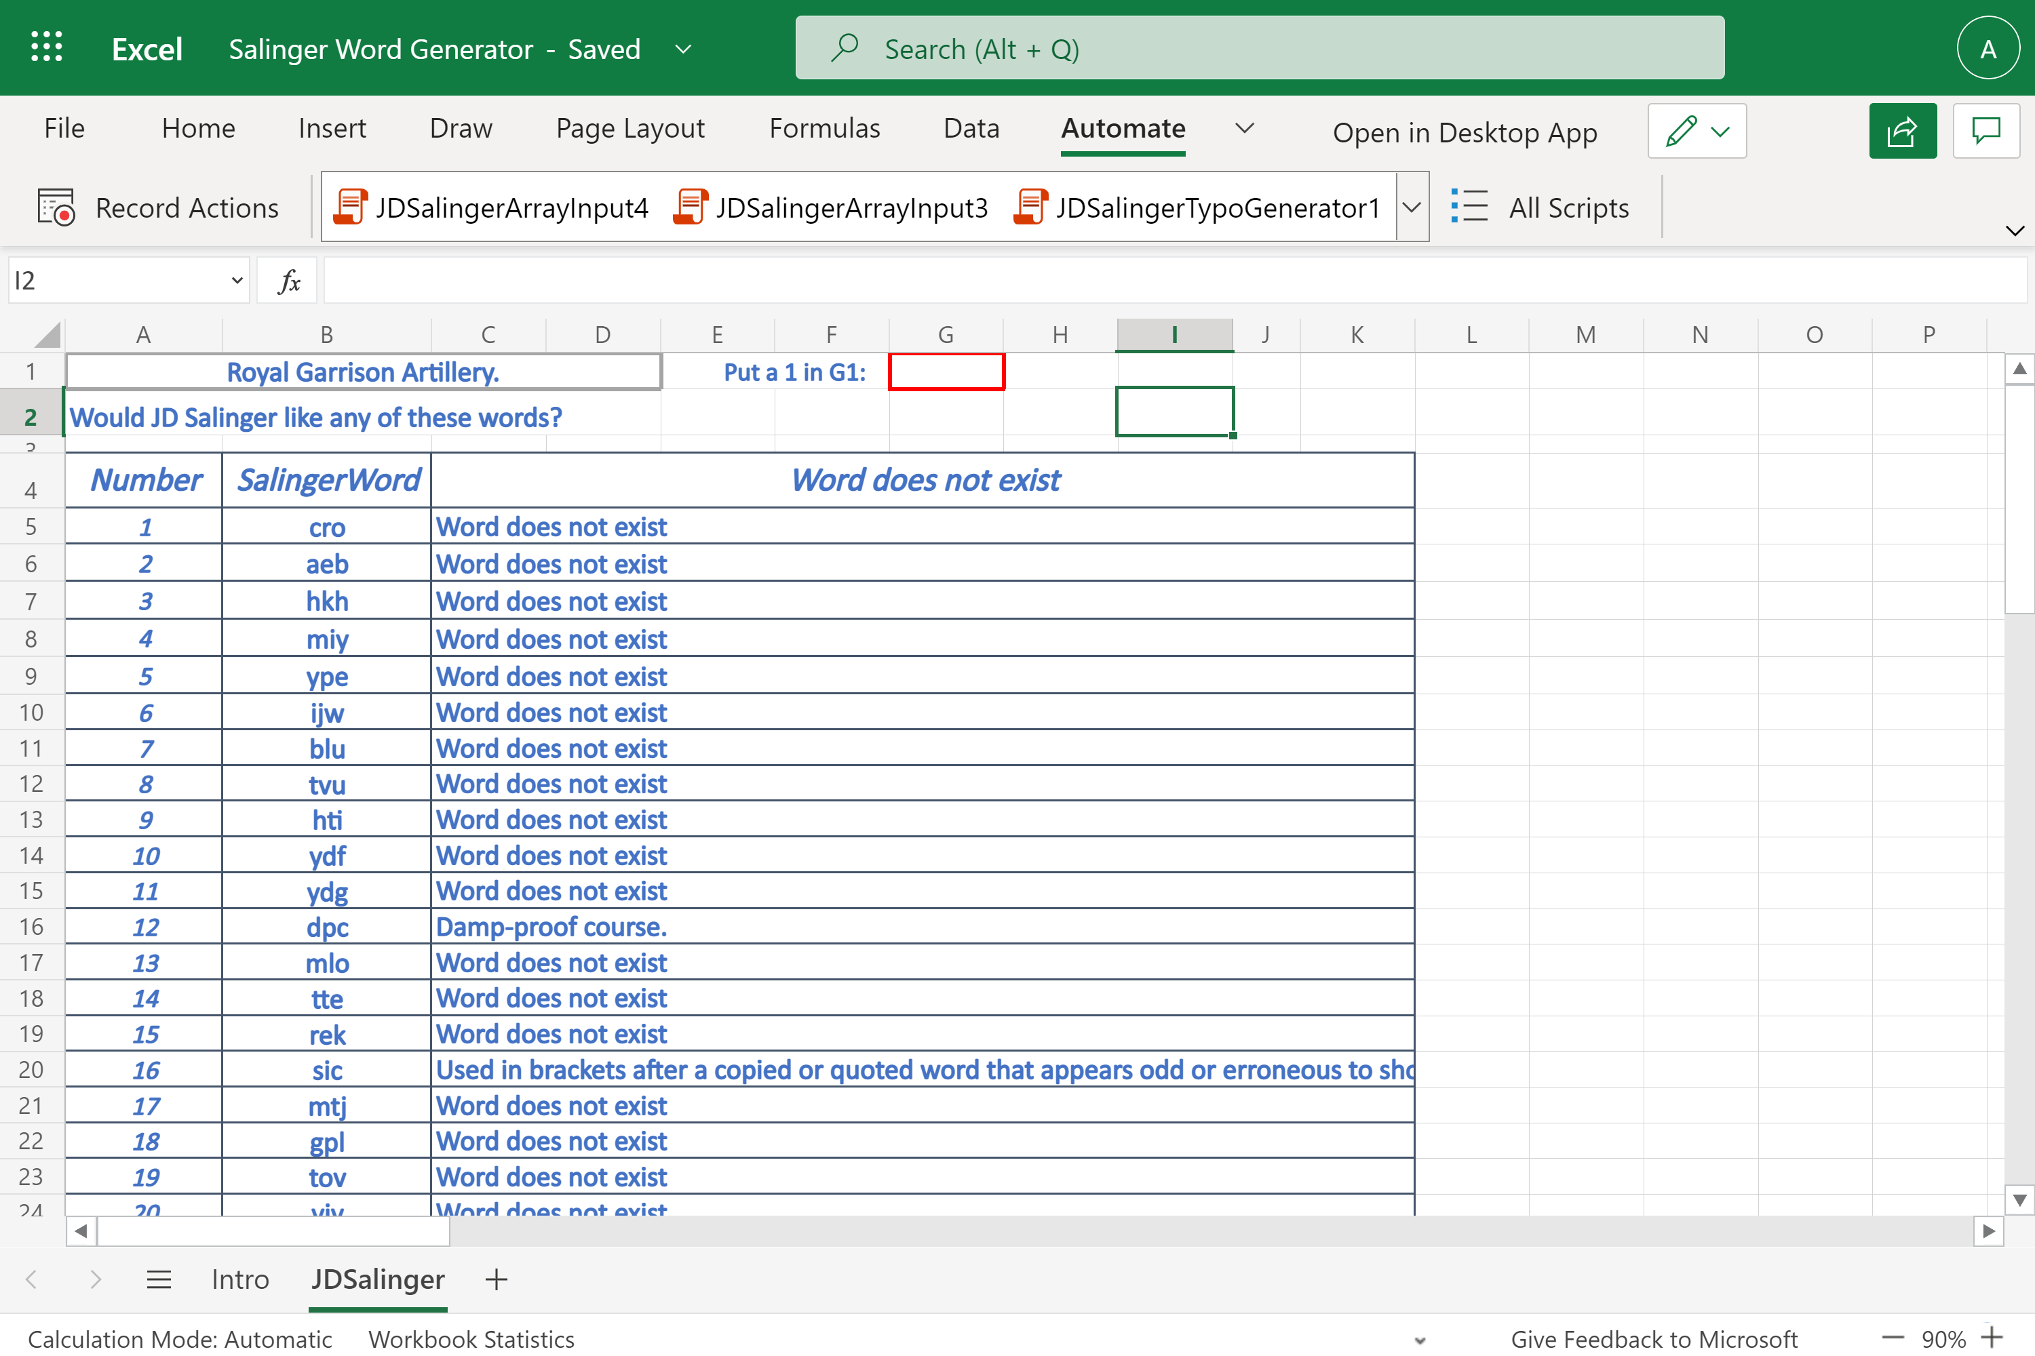

The scripts used in this demo are supplied separately as .ts files, in the associated GitHiub repo, and are included at the end of this Word document.

**The Power Automate Flow**

**Fig 3. The entire flow**

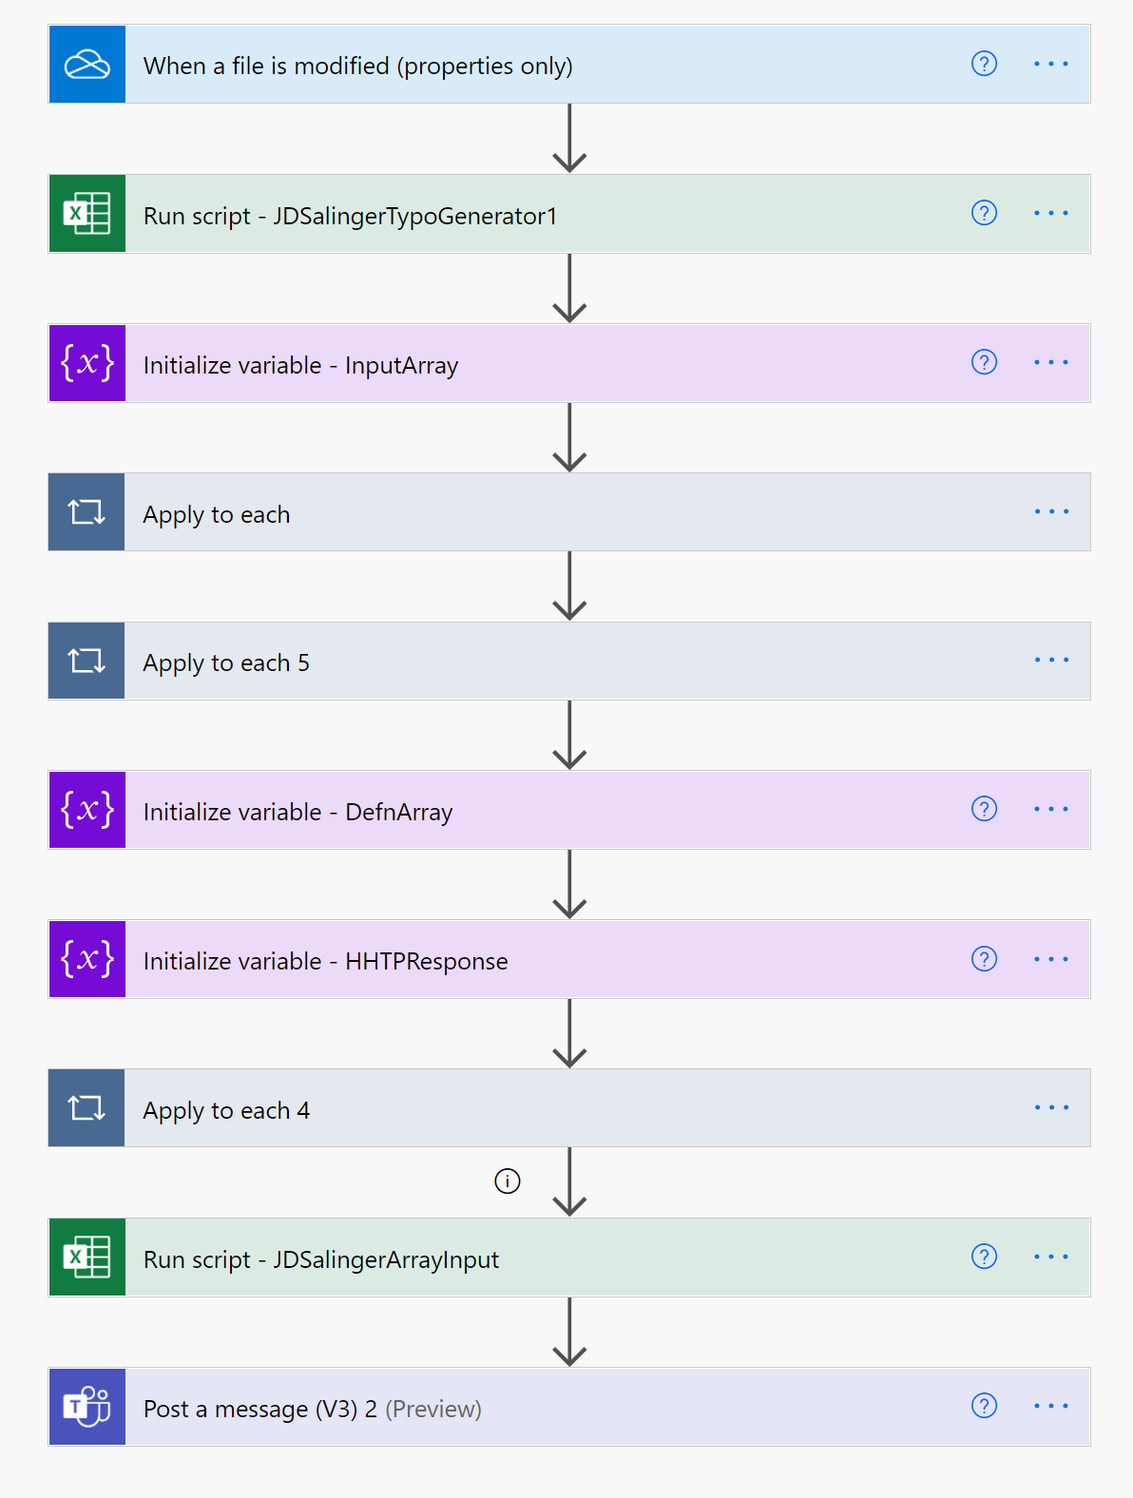

As can be seen, the Flow uses two Office Scripts. One to generate the Salinger Words and one to input the generated definitions back into the Excel Workbook. Here is a step-by-step look at each step in the entire flow.

The flow is triggered by a change in the Workbook. That is, when a 1 is entered into cell G1. The Office Script, then, runs. The Apply to each loop uses the array variable *InputArray* to hold the generated twenty 3-letter words.

**Fig 4. The InputArray stores the generated twenty, 3-letter, Salinger Words.**

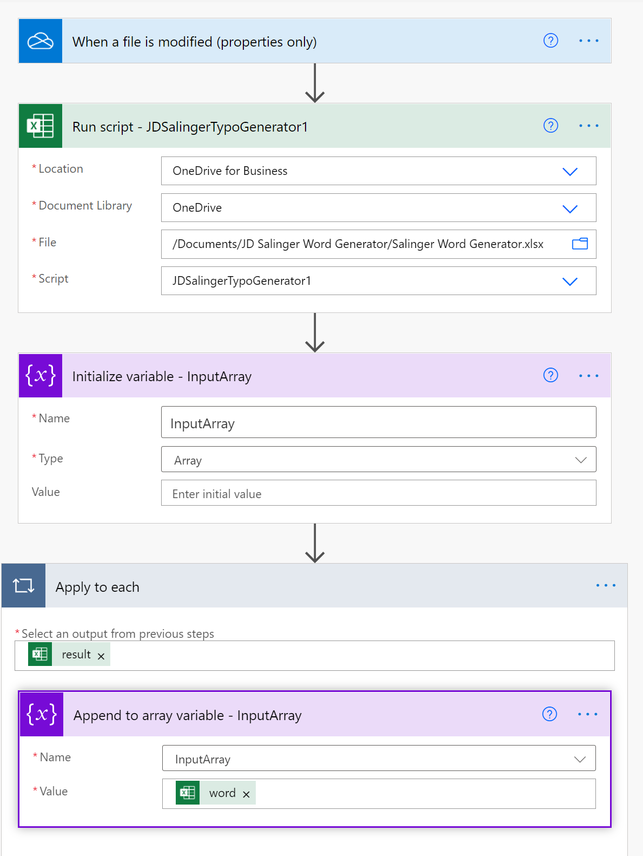

The twenty Salinger words are output to a Teams channel, as part of the debug checking process. Two variables, *DefnArry* and *HTTPResponse* are created. The DefnArray variable holds the list of retrieved definitions for each of the 20 Salinger words. The HHTPReponse variable contains the HTTP code 404 which “indicates that the browser was able to communicate with a given server, but the server could not find what was requested”. The HTTP connector connects with the free a Dictionary REST API from Dicionaryapi.dec : [Free Dictionary API](https://dictionaryapi.dev/).

**Fig 5. The Salinger Words are posted to Teams**

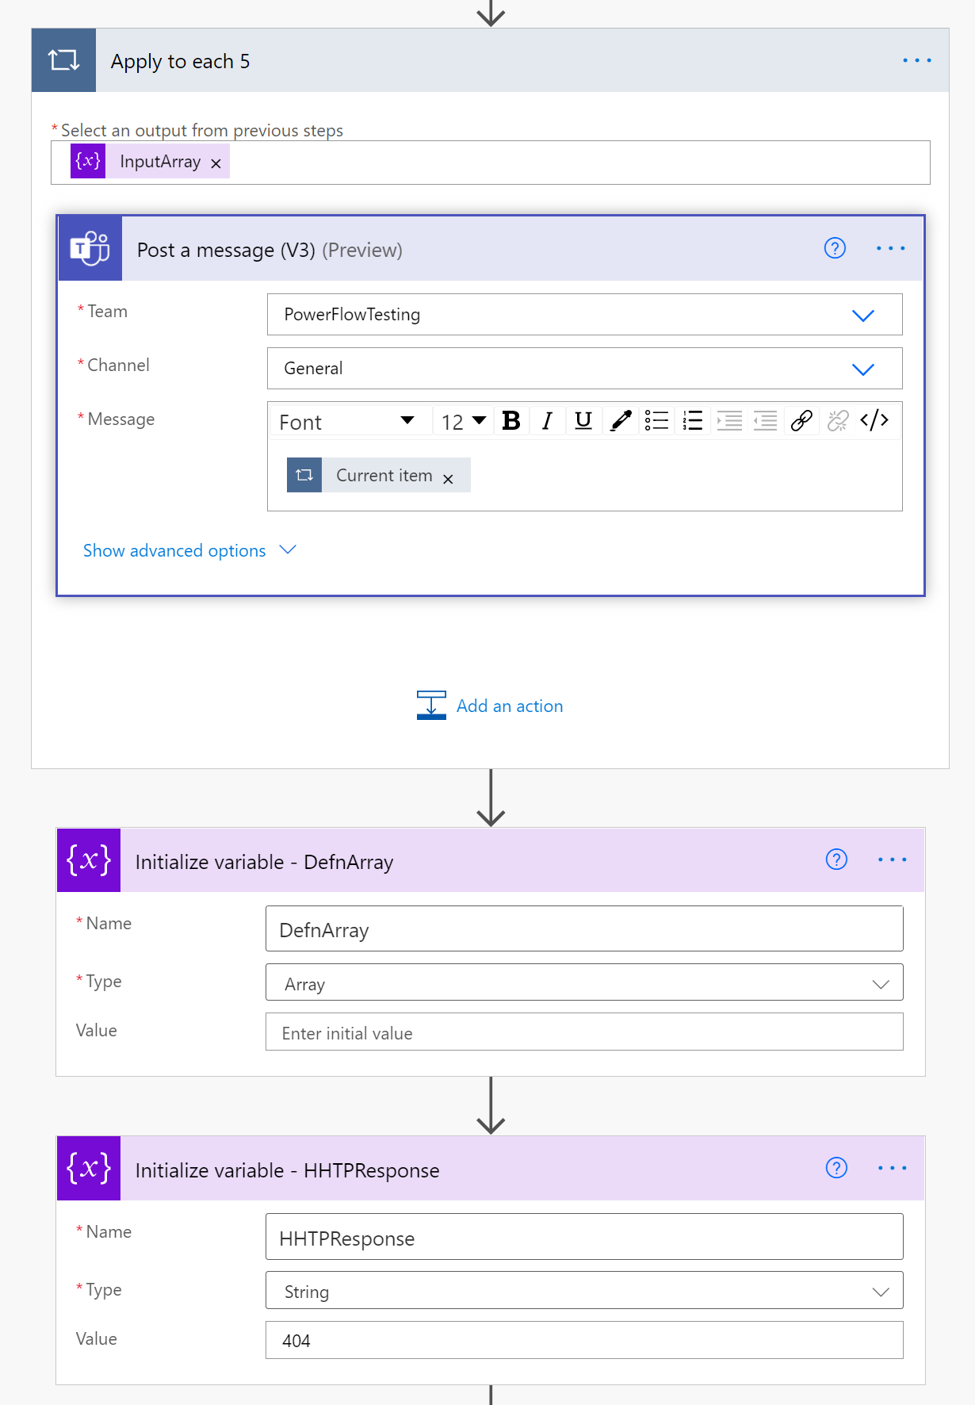

In the “Apply to each 4” loop, the definitions for each of the Salinger words are retrieved using the HTTP connector and added to the DefnArray. See Fig 6.

**Fig 6. The “Apply to each 4” loop.**

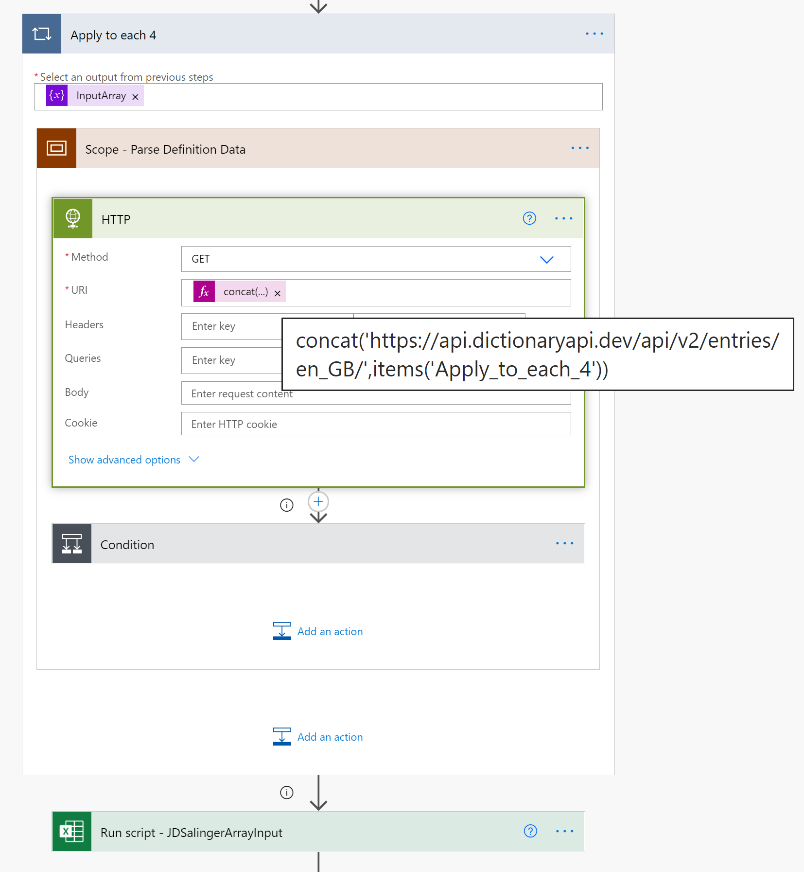

Where no definition is available the response, from the HTTP connector is 404. This value is contained within the status code response. In the condition step, see Fig 7 below, the formula “string(outputs('HTTP')['statusCode'])” is compared to the value 404. If true then the “No Word Exists” text is added as item (value) to the DefnArray. If the condition is false then a definition has been found and it is extracted from the HTTP Body response value.

**Fig 7. Condition evaluates to TRUE or FALSE adding the HHTP connector response to the DefnArray**

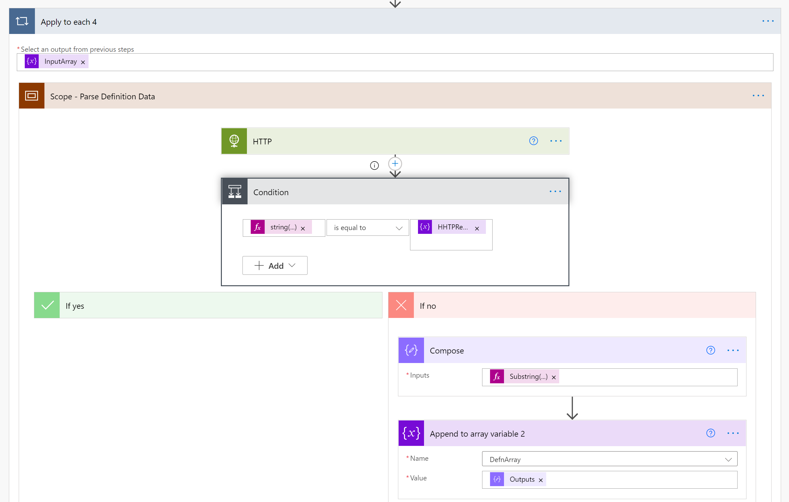

The definition string extraction formula is as follows :

Substring(substring(Substring(string(body('HTTP')),indexOf(string(body('HTTP')),'definitions'),sub(lastIndexOf(string(body('HTTP')),']'),indexOf(string(body('HTTP')),'definitions'))),29,sub(lastIndexOf(Substring(string(body('HTTP')),indexOf(string(body('HTTP')),'definitions'),sub(lastIndexOf(string(body('HTTP')),']'),indexOf(string(body('HTTP')),'definitions'))),']'),29)),0,indexOf(substring(Substring(string(body('HTTP')),indexOf(string(body('HTTP')),'definitions'),sub(lastIndexOf(string(body('HTTP')),']'),indexOf(string(body('HTTP')),'definitions'))),29,sub(lastIndexOf(Substring(string(body('HTTP')),indexOf(string(body('HTTP')),'definitions'),sub(lastIndexOf(string(body('HTTP')),']'),indexOf(string(body('HTTP')),'definitions'))),']'),29)),'"'))

Even though the HTTP Response was in JSON format and Parse JSON connectors do operate on this response, they could not be used in this case for practical reasons. This was because the JSON syntax changes, dynamically, depending on the number of *partOfSpeech* items in the JSON response. That is, the JSON changes when a definition contains of adverb, verb, noun, adjective and so on. Each word has a variable amount of these and the JSON for the two examples, as provided in Appendix 1 and 2, in this document, ranges from 1 page to 7 pages. So, there is a huge difference in the size and number of layers for each JSON response for each word definition retrieved. Creating a set of PARSE Json operations as well as the associated loops and variables to manage this would be onerous to create. An alternative much easier method was possible. As can be seen in Fig 8, the string extraction formula was used. It extracts the first definition it encounters ignoring all subsequent definitions with that same response body. Each response can contain up to 7 or, even, more definitions. Only the first one was extracted.

**Fig 8. The definition string extraction formula**

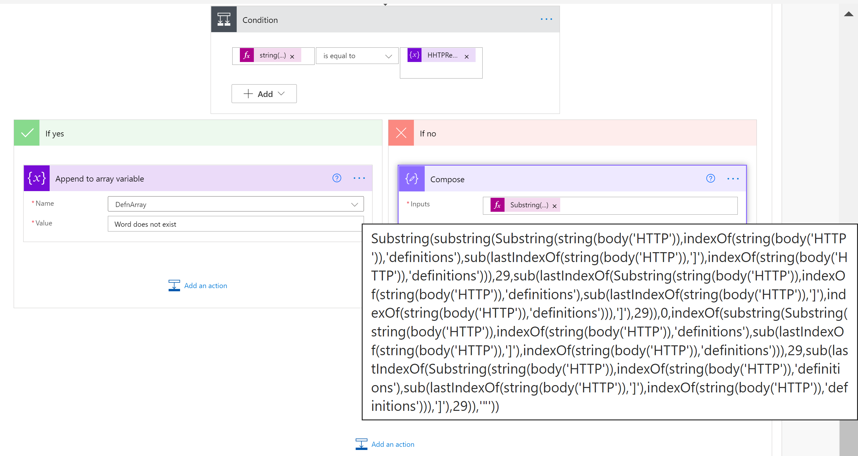

**Fig 9.** **The final Office Script input the definitions, found, into Excel.**

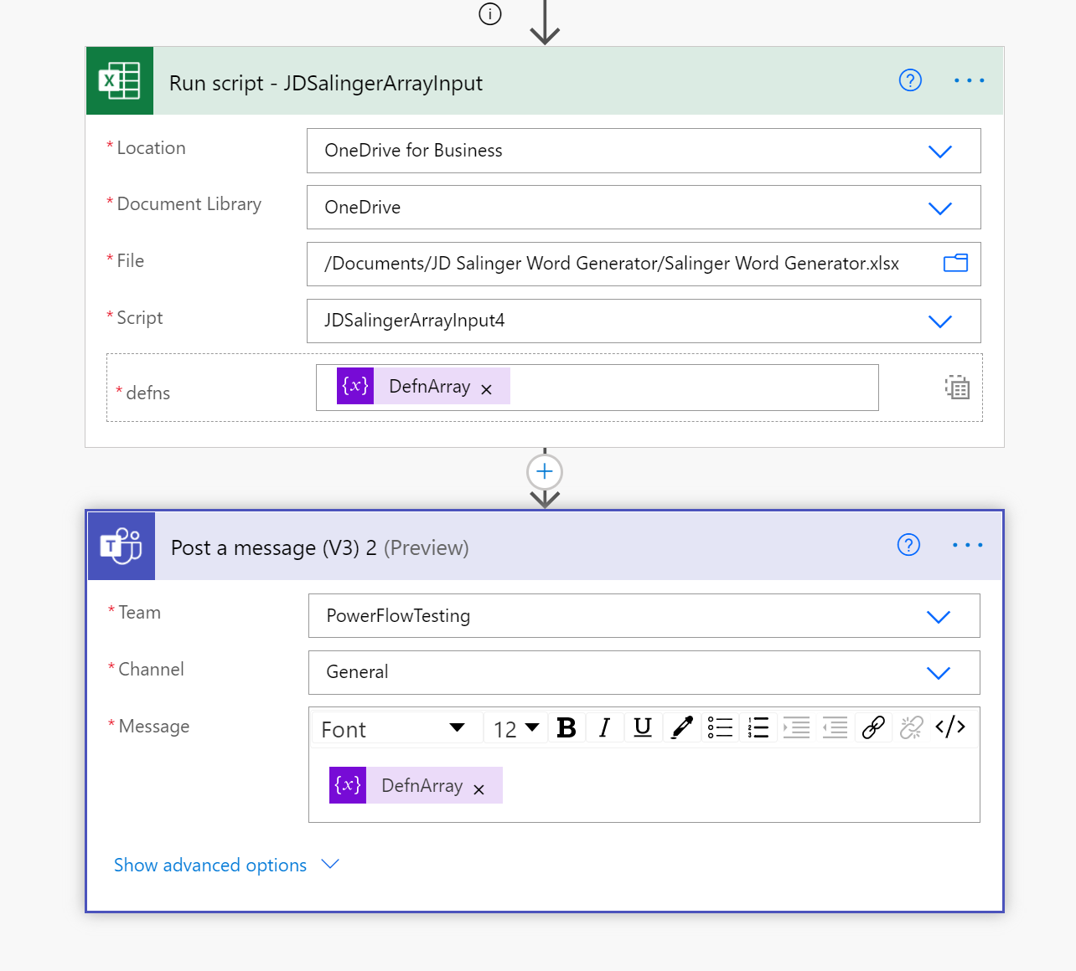

**Further Notes**

The HTTP Get Connector uses the following url and syntax, for example,

[**https://api.dictionaryapi.dev/api/v2/entries/en_GB/trying**](https://api.dictionaryapi.dev/api/v2/entries/en_GB/trying)

**Example Salinger words and retrieved definitions.**

'hgsgs' Word does not exist

'today' On or in the course of this present day.

'maybe' Perhaps; possibly.

'down' From a higher to a lower point of (something)

'up' From a lower to a higher point of (something)

'right' Restore to a normal or upright position.

'left' On or to the left side.

'always' At all times; on all occasions.

'never' At no time in the past or future; not ever.

'enterprise' A project or undertaking, especially a bold or complex one.

**The DefnArray**

["Word does not exist","On or in the course of this present day.","Perhaps; possibly.","From a higher to a lower point of (something)","From a lower to a higher point of (something)","Restore to a normal or upright position.","On or to the left side.","At all times; on all occasions.","At no time in the past or future; not ever.","A project or undertaking, especially a bold or complex one."]

Within this array some of the definitions contain comma symbols. To split the array using the split marker “,” does not work. See the second Office Script example, **JDSalingerArrayInput3,**  showing how this was managed.

**GitHub Repo location**

[OfficeScripts/JDSalingerWordGenerator at main · MrAnalyticals/OfficeScripts (github.com)](https://github.com/MrAnalyticals/OfficeScripts/tree/main/JDSalingerWordGenerator)

**YouTube Video Location**

[**https://youtu.be/GprM8uMOcac**](https://youtu.be/GprM8uMOcac)

**The Office Scripts**

**JDSalingerTypoGenerator**

function main(workbook: ExcelScript.Workbook): wordsArray[] {

  let JDSheet = workbook.getWorksheet('JDSalinger')

  let wordsArrayObjects: wordsArray[] = []

  let randomSalingerWord: String = ''

  let randomLetterNumber: number

  let randomLetter: string

  let test: string = ''

  let testy: string = ''

  let g1 = JDSheet.getRange('g1').getValue().toString()

  console.log('g1: ' + g1)

  if (g1 == '1'){

    JDSheet.getRange("g1").clear(ExcelScript.ClearApplyTo.contents)

  JDSheet.getRange("b5:b24").clear(ExcelScript.ClearApplyTo.contents)

for(let j = 4; j<24;j++){

  for (let i = 1; i < 4; i++) {

    randomLetterNumber = Math.floor(Math.random() * 26) + 1

    while (randomLetterNumber=26) {

      randomLetterNumber = Math.floor(Math.random() * 26) + 1

      if(randomLetterNumber!=26)

      break

    }

    //testy = randomLetterNumber.toString() + testy

    JDSheet.getCell(1, 5).setFormula("=CHAR(" + (randomLetterNumber + 65).toString() + ")")

    randomLetter = JDSheet.getCell(1, 5).getValue().toString()

    randomSalingerWord = lowercase(workbook, randomLetter) + randomSalingerWord

  }

  JDSheet.getCell(j, 1).setValue(randomSalingerWord)

  //let word: string

  let word = randomSalingerWord

  wordsArrayObjects.push({word: word as string})

  randomLetter = ''

  randomSalingerWord = ''

  }

  JDSheet.getRange("F2").clear(ExcelScript.ClearApplyTo.contents)

  }

  //console.log('g1 = ""')

  return wordsArrayObjects

}

function lowercase(workbook: ExcelScript.Workbook, letter: string): string {

  switch (letter) {

    case 'A':

      return 'a'

    case 'B':

      return 'b'

    case 'C':

      return 'c'

    case 'D':

      return 'd'

    case 'E':

      return 'e'

    case 'F':

      return 'f'

    case 'G':

      return 'g'

    case 'G':

      return 'g'

    case 'H':

      return 'h'

    case 'I':

      return 'i'

    case 'J':

      return 'j'

    case 'K':

      return 'k'

    case 'L':

      return 'l'

    case 'M':

      return 'm'

    case 'N':

      return 'n'

    case 'O':

      return 'o'

    case 'P':

      return 'p'

    case 'Q':

      return 'i'

    case 'R':

      return 'r'

    case 'S':

      return 's'

    case 'T':

      return 't'

    case 'U':

      return 'u'

    case 'V':

      return 'v'

    case 'W':

      return 'w'

    case 'X':

      return 'e'

    case 'Y':

      return 'y'

    case 'Z':

      return 'a'

  }

}

interface wordsArray {

  word: string

}

**JDSalingerArrayInput3 (Uses an interim string correction step)**

function main(workbook: ExcelScript.Workbook, defns: definitionsArray[]) {

  //console.log('defns : ' + defns)

  let JDSalinger = workbook.getWorksheet('JDSalinger')

  let defns1 = ["Word does not exist", "Word does not exist", "Word does not exist", "Word does not exist", "Royal Garrison Artillery.", "Word does not exist", "Word does not exist", "Word does not exist", "A sweet, especially an inexpensive, one of a type intended mainly for children.", "Word does not exist", "Word does not exist", "Word does not exist", "Word does not exist", "Word does not exist", "Word does not exist", "Word does not exist", "Word does not exist", "Word does not exist", "Word does not exist", "Word does not exist"]//used for testing only   //let defnsStr = defns1.toString()  //use this line for testing

  //the static array above

  let defnsStr = defns.toString()

  if(defnsStr.length==0){

    return

  }

  console.log('defnsStr: ' + defnsStr)

  let defnsValR = defnsStr.replace(', ', ' ')

  //Same as replaceAll below

  let defnsValR1 = defnsValR.split(', ').join(' ')

  console.log('defnsValR1 joined: ' + defnsValR1)

  let defnsArray = defnsValR1.split(',')

  let j: number = 0

  j = 4

  for (let defnsVal of defnsArray) {

    JDSalinger.getCell(j, 2).setValue(defnsVal)

    j++

    if(j==24){

      break

    }

  }

let k: number

  console.log('JDSalingerArrayInput3 Routine finished')

}

interface definitionsArray {

  definition: string

}

**JDSalingerArrayInput4 Uses the input array unaltered)**

function main(workbook: ExcelScript.Workbook, defns: definitionsArray[]) {

  //console.log('defns : ' + defns)

  let JDSalinger = workbook.getWorksheet('JDSalinger')

  let defns1 = ["Word does not exist", "Word does not exist", "Word does not exist", "Word does not exist", "Royal Garrison Artillery.", "Word does not exist", "Word does not exist", "Word does not exist", "A sweet, especially an inexpensive, one of a type intended mainly for children.", "Word does not exist", "Word does not exist", "Word does not exist", "Word does not exist", "Word does not exist", "Word does not exist", "Word does not exist", "Word does not exist", "Word does not exist", "Word does not exist", "Word does not exist"] //used for testing

  //let defnsStr = defns1.toString()  //use this line for testing

  //the static array above

  let defnsStr = defns.toString()

  if(defnsStr.length==0){

    return

  }

  console.log('defnsStr: ' + defnsStr)

  let defnsValR = defnsStr.replace(', ', ' ')

  //Same as replaceAll below

  let defnsValR1 = defnsValR.split(', ').join(' ')

  console.log('defnsValR1 joined: ' + defnsValR1)

  let defnsArray = defnsValR1.split(',')

  let j: number = 0

  let k: number

  for (let k = 0; k<21; k++) {

    j=k+4

    JDSalinger.getCell(j, 2).setValue(defnsArray[k])

    //console.log(defnsArray[k])

  }

  console.log('JDSalingerArrayInput4 Routine finished')

}

interface definitionsArray {

  definition: string

}

**References**

* Free REST API Dictionaries [Free Dictionary API](https://dictionaryapi.dev/), [WordsAPI](https://www.wordsapi.com/)
* Wikipedia Entry for JD Salinger https://en.wikipedia.org/wiki/My_Salinger_Year

**Appendix 1 Retrieved JSON for definition of word “DOWN”**

**Salinger Word - Input Word - Down**

[

  {

    "phonetics": [

      {

        "text": "/daʊn/",

        "audio": "https://lex-audio.useremarkable.com/mp3/down_gb_1.mp3"

      }

    ],

    "word": "down",

    "origin": "Old English dūn ‘hill’ (related to Dutch duin ‘dune’), probably ultimately of Celtic origin and related to Old Irish dún and obsolete Welsh din ‘fort’, which are from an Indo-European root shared by town.",

    "meanings": [

      {

        "partOfSpeech": "preposition",

        "definitions": [

          {

            "definition": "From a higher to a lower point of (something)",

            "synonyms": [

              "lower in",

              "lower on",

              "to the bottom of"

            ],

            "example": "up and down the stairs"

          },

          {

            "definition": "Throughout (a period of time)",

            "synonyms": [

              "throughout",

              "through",

              "during",

              "in"

            ],

            "example": "astrologers down the ages"

          }

        ]

      },

      {

        "partOfSpeech": "verb",

        "definitions": [

          {

            "definition": "Knock or bring to the ground.",

            "synonyms": [

              "knock down",

              "knock over",

              "knock to the ground",

              "throw to the ground",

              "bring down",

              "bring to the ground",

              "fell",

              "topple",

              "prostrate",

              "tackle",

              "rugby-tackle",

              "trip up"

            ]

          },

          {

            "definition": "Consume (something, typically a drink)",

            "synonyms": [

              "drink",

              "drink down",

              "drink up",

              "gulp",

              "gulp down",

              "guzzle",

              "quaff",

              "drain",

              "imbibe",

              "sup",

              "slurp",

              "suck",

              "sip",

              "swallow",

              "finish off",

              "polish off"

            ]

          }

        ]

      },

      {

        "partOfSpeech": "noun",

        "definitions": [

          {

            "definition": "A period of unwelcome experiences or negative mood.",

            "synonyms": [

              "setbacks",

              "upsets",

              "reverses",

              "reversals",

              "reversals of fortune",

              "downturns",

              "mishaps",

              "strokes of ill luck",

              "strokes of bad luck",

              "accidents",

              "shocks",

              "vicissitudes",

              "crises",

              "catastrophes",

              "tragedies",

              "calamities",

              "trials",

              "crosses",

              "knocks",

              "burdens",

              "blows",

              "buffets"

            ]

          },

          {

            "definition": "A chance for a team to advance the ball, ending when the ball carrier is tackled or the ball becomes out of play. A team must advance at least ten yards in a series of four downs in order to keep possession.",

            "example": "That weakness should not be too great of a negative since the Texans typically do not use a nose tackle on passing downs anyway."

          }

        ]

      },

      {

        "partOfSpeech": "adjective",

        "definitions": [

          {

            "definition": "Directed or moving towards a lower place or position.",

            "example": "the down escalator"

          },

          {

            "definition": "Unhappy or depressed.",

            "synonyms": [

              "depressed",

              "sad",

              "saddened",

              "unhappy",

              "melancholy",

              "miserable",

              "wretched",

              "sorrowful",

              "gloomy",

              "dejected",

              "downhearted",

              "disheartened",

              "despondent",

              "dispirited",

              "low",

              "in low spirits",

              "low-spirited",

              "heavy-hearted",

              "glum",

              "morose",

              "dismal",

              "downcast",

              "cast down",

              "tearful"

            ],

            "example": "he's been so down lately"

          },

          {

            "definition": "(of a computer system) temporarily out of action or unavailable.",

            "synonyms": [

              "not working",

              "not functioning",

              "not functional",

              "not in working order",

              "not in operation",

              "inoperative",

              "malfunctioning",

              "out of order",

              "broken",

              "broken-down",

              "acting up",

              "unserviceable",

              "faulty",

              "defective",

              "in disrepair"

            ],

            "example": "sorry, but the computer's down"

          },

          {

            "definition": "Supporting or going along with someone or something."

          },

          {

            "definition": "Denoting a flavour (variety) of stable quark having relatively low mass and an electric charge of −1/3. In the Standard Model protons and neutrons are composed of up and down quarks.",

            "example": "At this energy level, only up and down quarks, the electron and the electron neutrino exist."

          }

        ]

      },

      {

        "partOfSpeech": "adverb",

        "definitions": [

          {

            "definition": "Towards or in a lower place or position, especially to or on the ground or another surface.",

            "synonyms": [

              "towards a lower position",

              "downwards",

              "downstairs",

              "towards the bottom",

              "from top to bottom"

            ],

            "example": "she looked down"

          },

          {

            "definition": "To or at a lower level of intensity, volume, or activity.",

            "example": "keep the noise down"

          },

          {

            "definition": "In or into a weaker or worse position, mood, or condition.",

            "example": "the scandal brought down the government"

          },

          {

            "definition": "In or into writing.",

            "example": "Graham noted the numbers down carefully"

          },

          {

            "definition": "(with reference to partial payment of a sum of money) made initially or on the spot.",

            "example": "pay £5 down and the rest at the end of the month"

          },

          {

            "definition": "(of sailing) with the current or the wind."

          },

          {

            "definition": "(of the ball or a player in possession) not in play, typically through progress being stopped."

          }

        ]

      }

    ]

  },

  {

    "word": "down",

    "phonetics": [

      {

        "text": "/daʊn/",

        "audio": "https://lex-audio.useremarkable.com/mp3/down_gb_1.mp3"

      }

    ],

    "meanings": [

      {

        "partOfSpeech": "noun",

        "definitions": [

          {

            "definition": "Soft, fine, fluffy feathers which form the first covering of a young bird or an insulating layer below the contour feathers of an adult bird.",

            "synonyms": [

              "soft feathers",

              "fluff",

              "fuzz",

              "floss",

              "lint",

              "bloom",

              "fine hair",

              "nap",

              "pile"

            ],

            "example": "the baby penguins' woolly down is essential in the Antarctic winter"

          }

        ]

      }

    ]

  },

  {

    "word": "down",

    "phonetics": [

      {

        "text": "/daʊn/",

        "audio": "https://lex-audio.useremarkable.com/mp3/down_gb_1.mp3"

      }

    ],

    "meanings": [

      {

        "partOfSpeech": "noun",

        "definitions": [

          {

            "definition": "A gently rolling hill.",

            "example": "the gentle green contours of the downs"

          },

          {

            "definition": "A stretch of sea off the east coast of Kent, sheltered by the Goodwin Sands."

          }

        ]

      }

    ]

  },

  {

    "word": "Down",

    "phonetics": [

      {

        "text": "/daʊn/",

        "audio": "https://lex-audio.useremarkable.com/mp3/down_gb_1.mp3"

      }

    ],

    "meanings": [

      {

        "partOfSpeech": "proper noun",

        "definitions": [

          {

            "definition": "One of the Six Counties of Northern Ireland, since 1973 an administrative district; chief town, Downpatrick."

          }

        ]

      }

    ]

  }

]

**Appendix 2 Retrieved JSON for definition of word “TODAY”**

**Salinger Word - Input Word - Today**

[

  {

    "word": "today",

    "phonetics": [

      {

        "text": "/təˈdeɪ/",

        "audio": "https://lex-audio.useremarkable.com/mp3/today_gb_2.mp3"

      }

    ],

    "meanings": [

      {

        "partOfSpeech": "adverb",

        "definitions": [

          {

            "definition": "On or in the course of this present day.",

            "synonyms": [

              "this day",

              "this very day",

              "before tomorrow",

              "this morning",

              "this afternoon",

              "this evening"

            ],

            "example": "she's thirty today"

          }

        ]

      },

      {

        "partOfSpeech": "noun",

        "definitions": [

          {

            "definition": "This present day.",

            "synonyms": [

              "this day",

              "this very day"

            ],

            "example": "today is a rest day"

          }

        ]

      }

    ]

  }

]

**Appendix 3 The JD Salinger Literary Works**

* The Catcher in the Rye (1951)

* Nine Stories (1953)

* Franny and Zooey (1961)

* Raise High the Roof Beam, Carpenters and Seymour: An Introduction (1963)

* Odds and Ends